Aia Al-Qasab

T5616SN

Advanced Enterprise Server Environment

Lab 6

**Lab 6. Multi-Host Management with VMware vCenter Server**

March 2019



**Lab 6. Multi-Host Management with VMware vCenter Server**

**I did the lab with Vo Khoa, it took two days to get the final results. We got a lot of problems during the lab, the VMs didn’t worked well for that reason step 8 doesn’t has many screenshots and step 7.**

**Step 1. Preparation**

- For this lab, you need to log in to the physical computer as the **Cisco user**

- **Before starting any lab VMs, ensure that the VMnet8 network adapter is enabled and has the preferred DNS server set to 192.168.163.100** (the IP of the vCenter Server VM, which is also configured to be the DNS server for this lab).

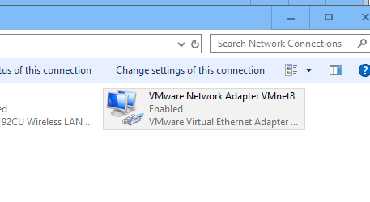

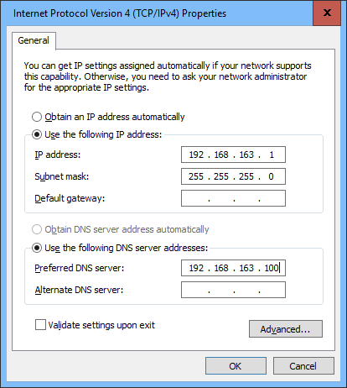

**Step 2. Preparing for Multi-Host Management with the vCenter Server and Web Client**

- Start the **vCenter** VM (a Windows server with the vCenter Server software installed) and **wait for the log in screen to appear** (no need to login) before starting the next VMs.

o When the **vCenter** VM is ready, also start the **ESXi-01** and **ESXi-02** VMs.

o All the VMs can be running in the background during the lab, so you can minimize the VM windows.

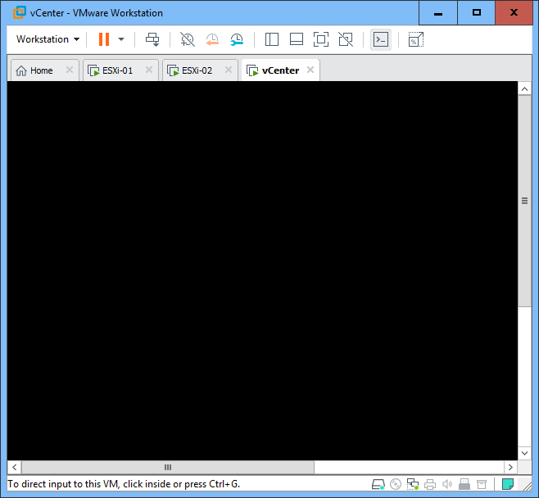

- While waiting for the VMs to boot, please read this background information of the lab arrangement:

o In this lab, you practice **managing multiple ESXi hosts with vCenter Server** and configuring some **advanced features**.

o There are two options for **installing the vCenter Server**:

▪ By using **vCenter Server Appliance**, which is a **preconfigured Linux-based virtual machine** (provided as a template by VMware) that is optimized for running vCenter Server. However, the appliance does not include an installation of the Web Client, which must be installed to a separate Windows Server (cannot be installed to a desktop Windows). So when using the appliance version, you probably need separate server(s) for the Web Client.

▪ By installing the **vCenter Server** software with Windows installer to a **Windows Server**. This includes all the software needed by the tool (a database, single sign-on support, Web Client). **We use this option in this lab**.

▪ Check: https://www.vmware.com/files/pdf/techpaper/vmware-vcenter-server6-deployment-guide.pdf

o To connect to the vCenter Server, we have two main options

▪ The **vSphere Client** can be used for multi-server management with vCenter Server BUT it does not support the latest techniques.

▪ The **Web Client** is the recommended client and we have it installed in the vCenter Server VM. We use this option in this lab.

- Open a web browser (in the host OS) and browse to the **vCenter** VM (use the IP **192.168.163.100**). The server has not been configured with a valid security certificate, so you may get a warning about it. Just confirm the security exception.

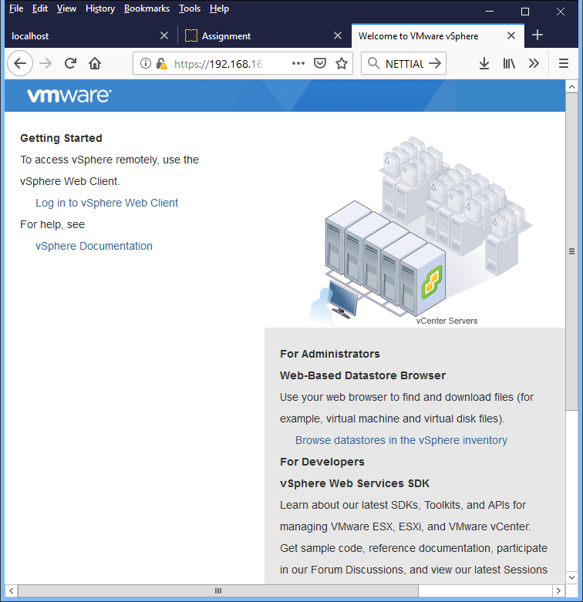

- Click “**Log in to vSphere Web Client**”

o The vSphere Client web server software in the vCenter Server VM takes some time to initialize, so if you get a message about this, just wait a bit and try again…

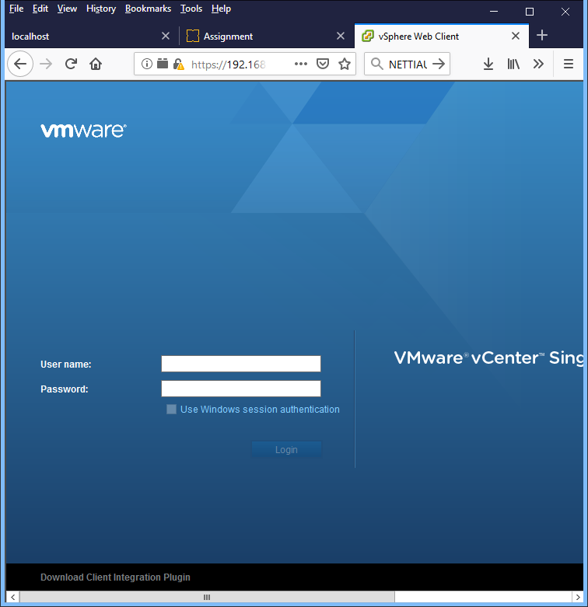

- The **vCenter Server** VM doesn’t have a valid certificate, so you will get a warning. Just accept the warning.

- You should now be in the **vCenter Server Single Sign-On** page.

o Check if the browser notifies you about any **plugins** that are required. If yes, allow (and remember) them.

o You can **bookmark** this page for easier access in the future.

o On the bottom of the page, download the **Client Integration Plugin** and install it.

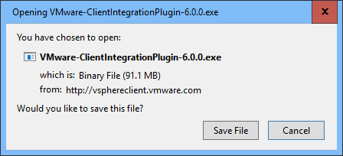

- Browse back to the vCenter Server Single Sign-On page and login as **administrator@vsphere.local** / **P@ssw0rd**

o Notice that in real installations, it is also possible to use your Windows login account, which means the authentication and authorization is made through the Active Directory

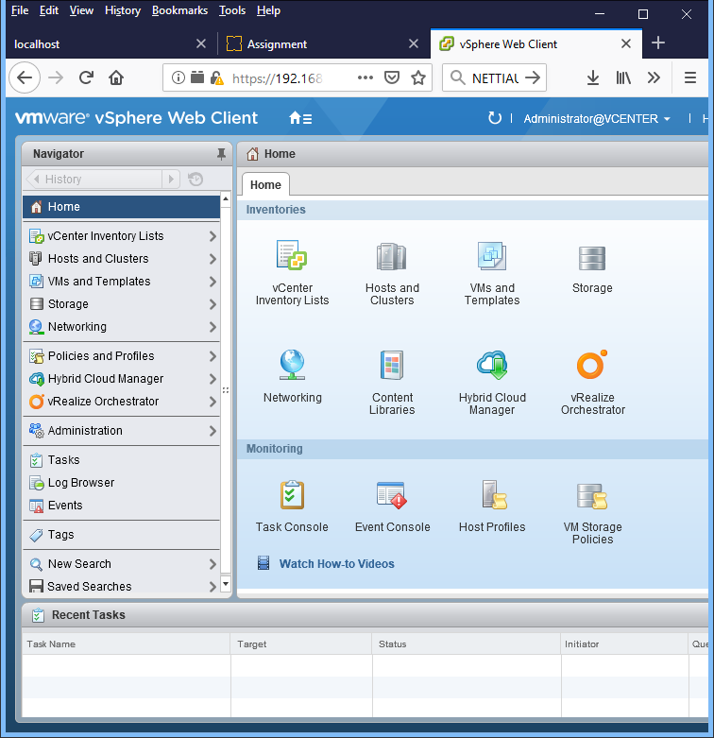

- The tool takes about a minute to load, so be patient. In case the tool doesn’t load at all (the web page just stays blue and there’s no clock-type mouse pointer indicating load status), just try refreshing the page (probably you need to allow the Flash plugin).

- Investigate the main structure of the **Web Client** tool:

o **Navigator** in the left

o **Content area** in the middle

o **Help** & **Search** in the top right corner

o **Alarms** & **Work in Progress** in the right

o **Recent Tasks** on the bottom

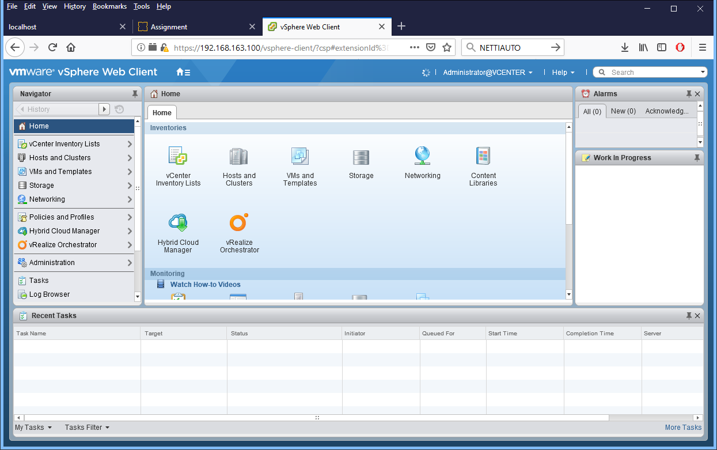

**Step 3. Working with Licenses**

- Check the **Alarms** from the right side of the page: the vCenter Server license has been expired (or is close to expiration)!

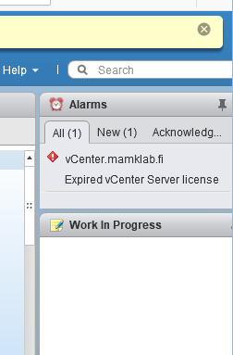

o Click the alarm message to show the details. Notice that you can click **Acknowledge** to tell the system that you have received the message and do no longer want to see the Alarm in the list. Alternatively, you can change the alarm status as **Green**, telling the system that everything is ok, this alarm has been dealt with.

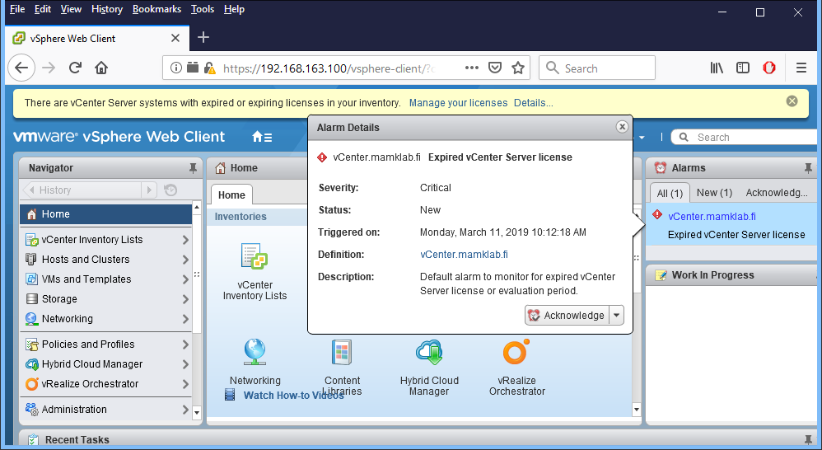

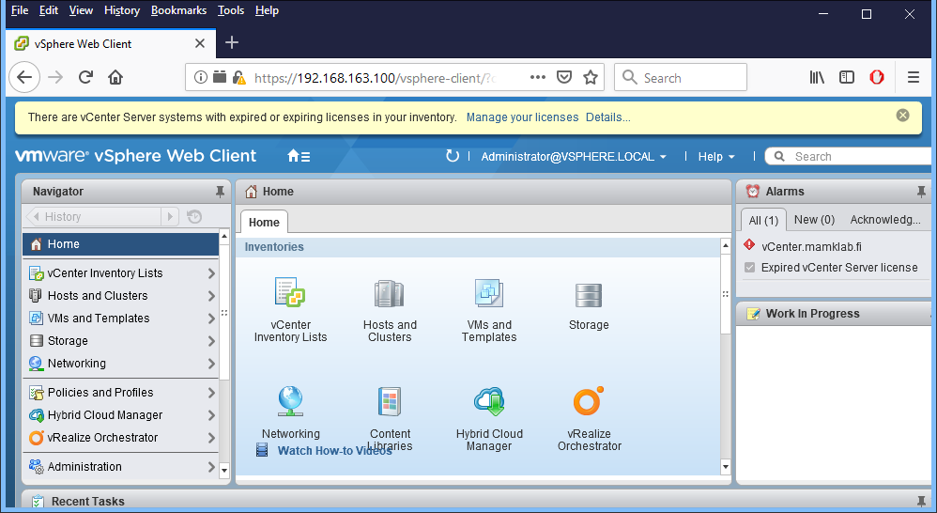

- There is also a notification message on top of the page, telling that “*There are vCenter Server systems with expired or expiring licenses in your inventory*.” Click “**Manage your licenses**” after the message to see your current licenses.

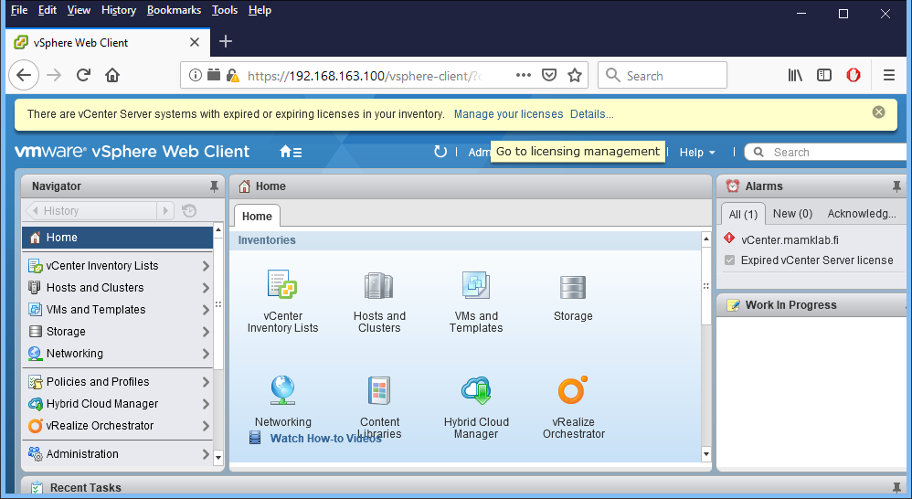

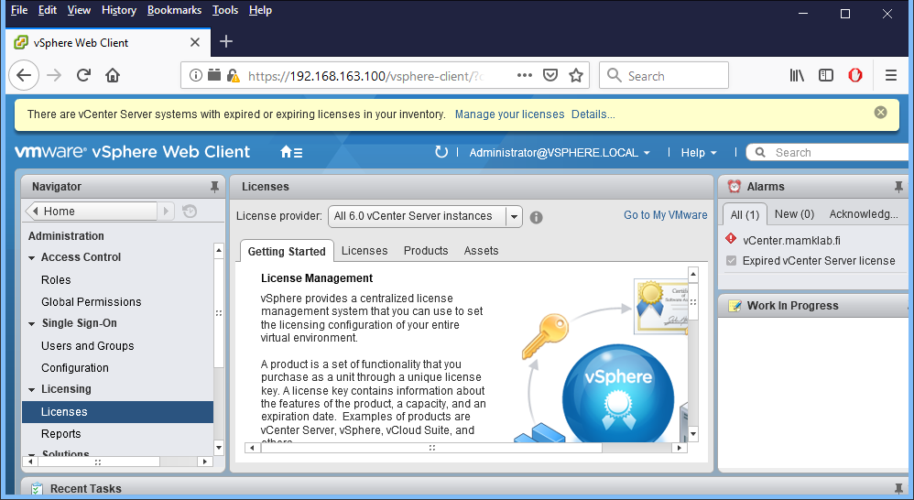

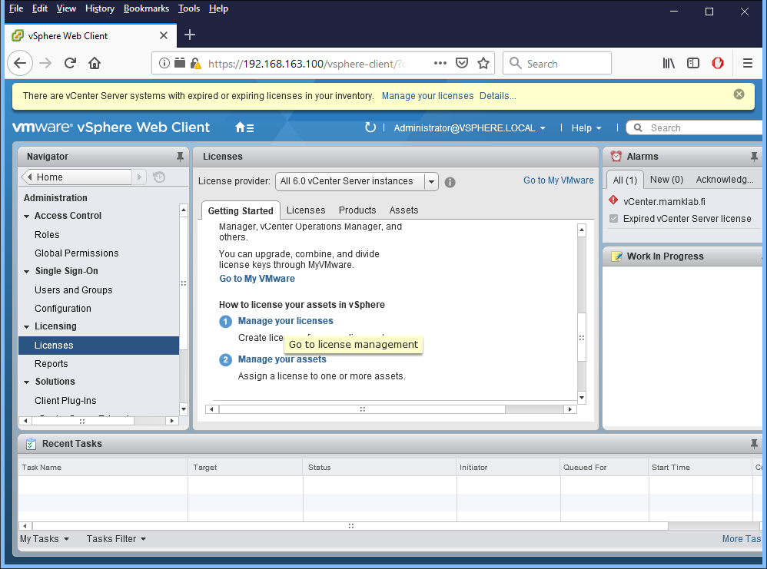

- Currently, there is one license named **LabLicense** and the expiration date is 27th of March, 2018. Click the license to see more details.

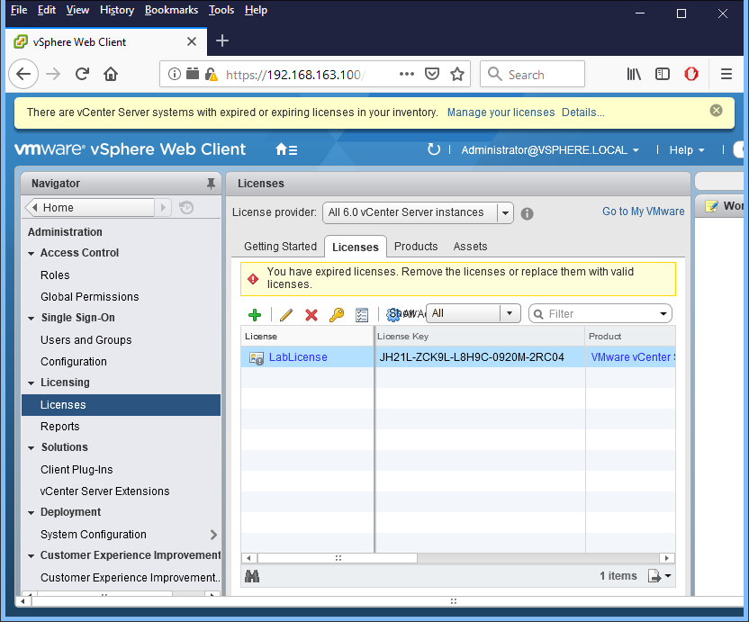

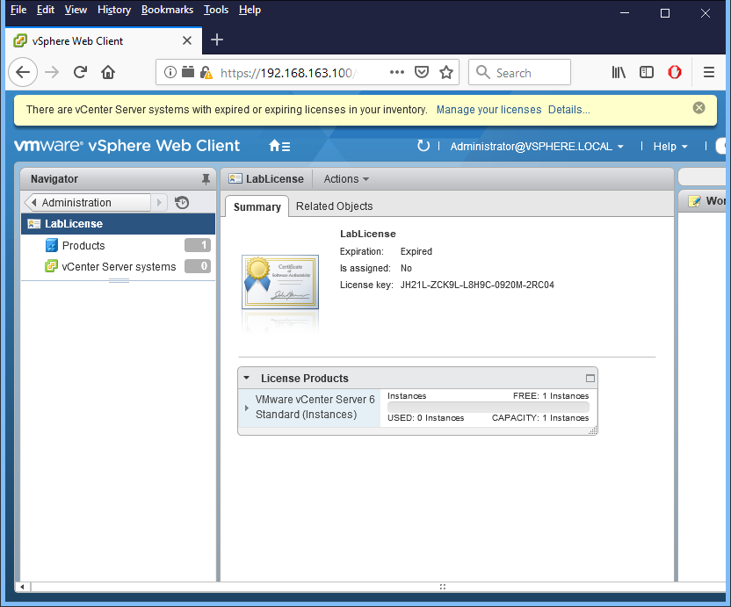

- Add a new license for the vCenter Server. Use license code **NN61H-NCL0N-8869A-012R2-2HCM5** and name the license with **your own name**.

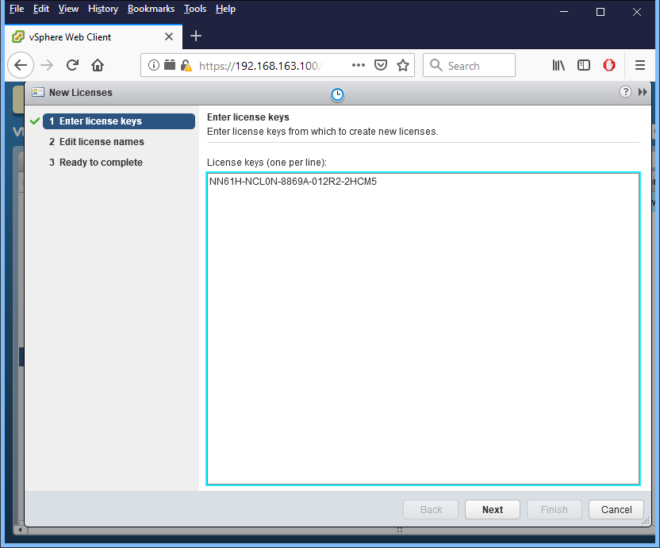

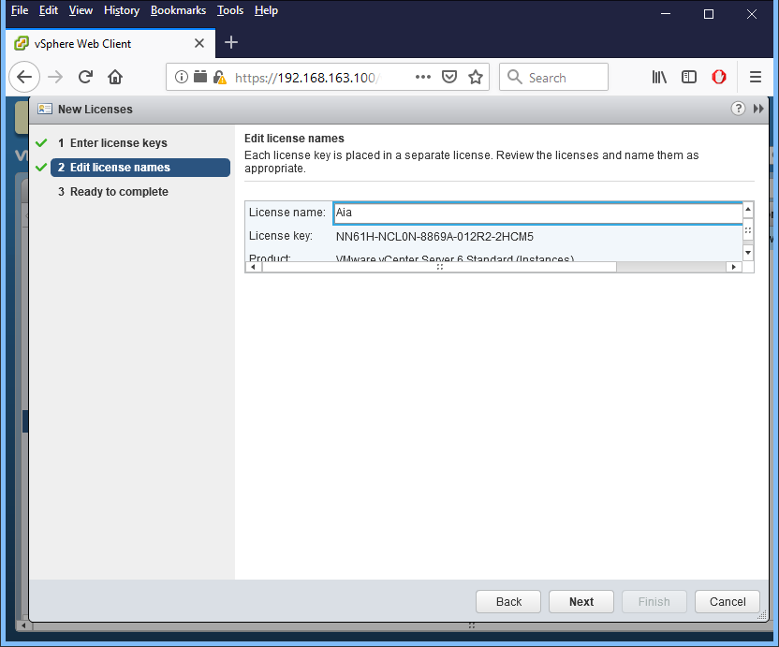

o *Add a screenshot of the current licenses to your* ***report.***

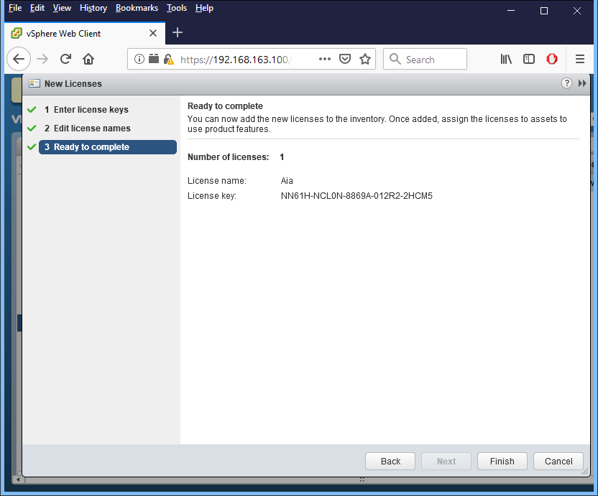

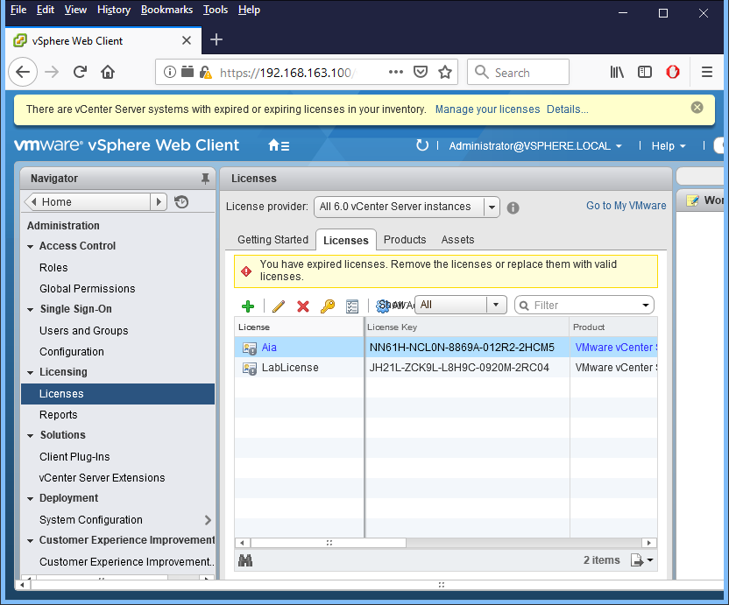

- Also be sure to **assign the new license** to get it into use. *Also add a screenshot to your* ***report*** *of the new license that is assigned and in use****.***

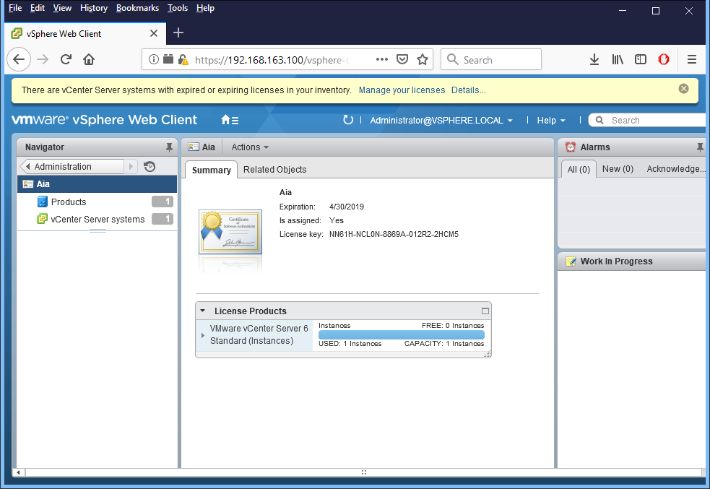

- Now you can close the notification message on top of the page by clicking the X on the right.

**Step 4. Creating Datacenters and Clusters**

- In the Home view, click **Hosts and Clusters**

- Investigate the usage of datacenters and clusters in the VMware environment

o Click “**Learn about datacenters**” and read the information.

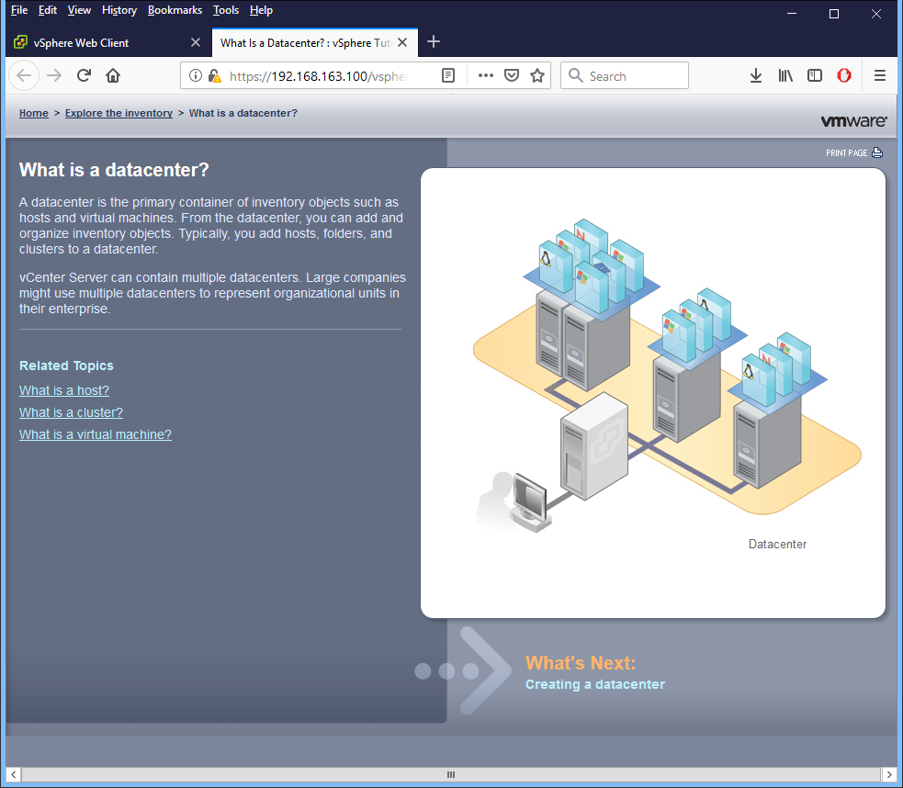

o Also check the Related Topics, especially “**What is a cluster?**”

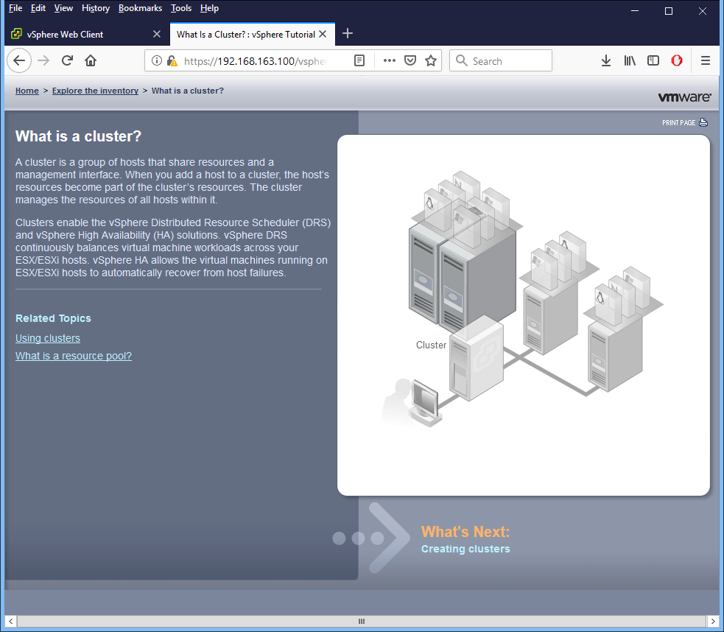

- Add a new datacenter: **DC-YourName**

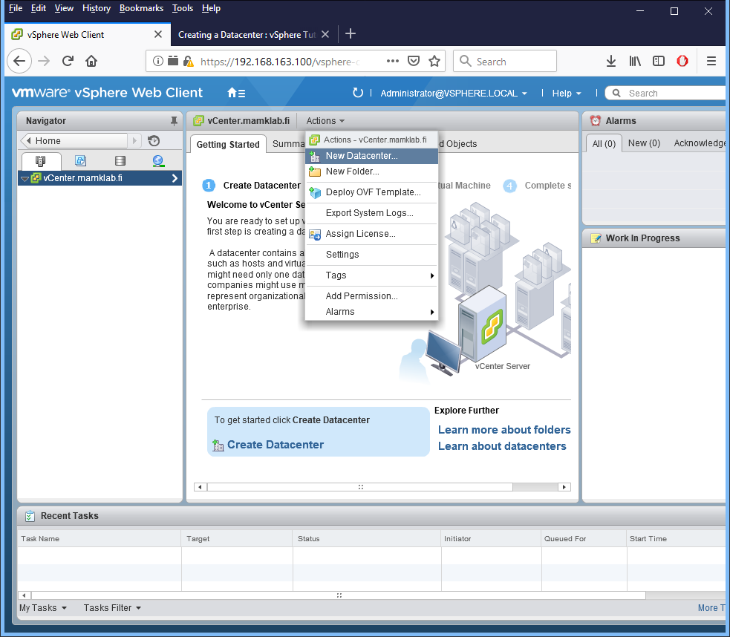

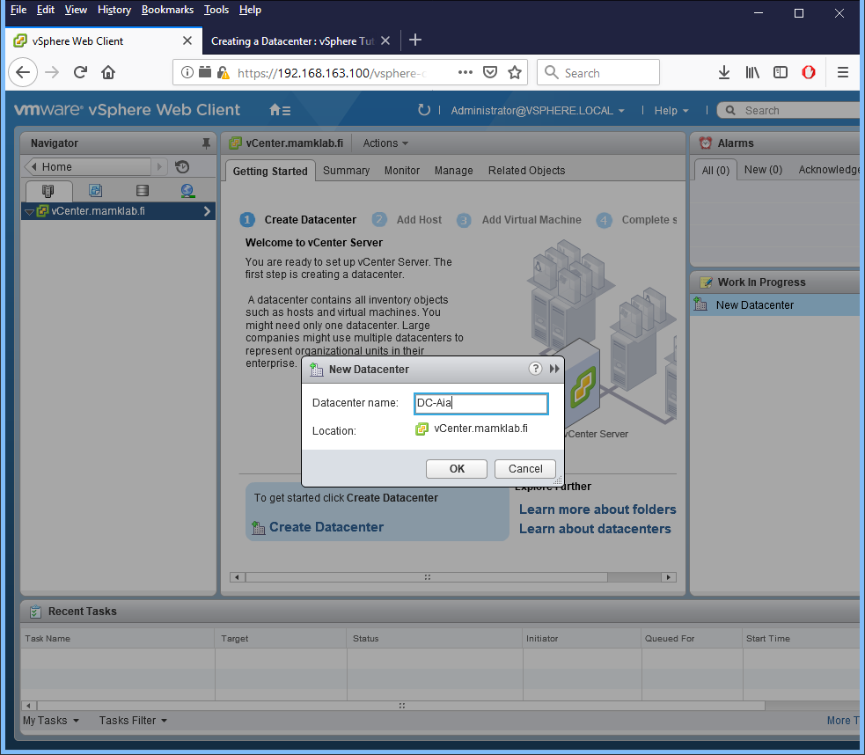

- Go to the datacenter and create a new cluster: **Cluster-YourName**

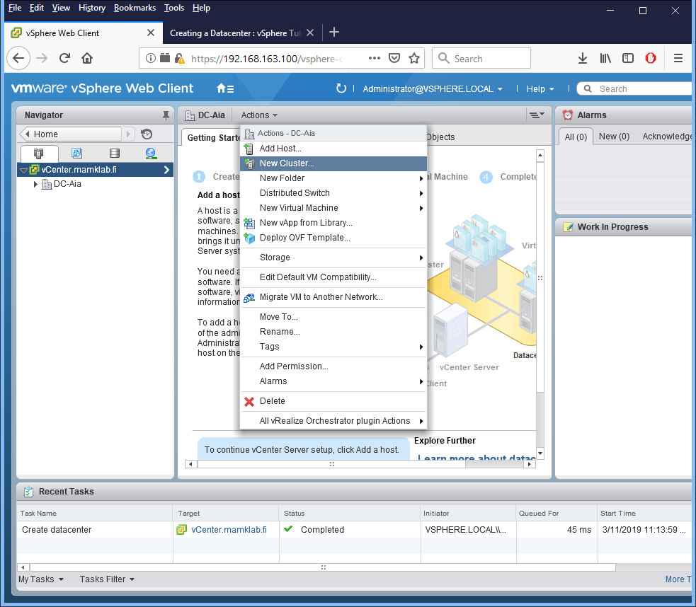

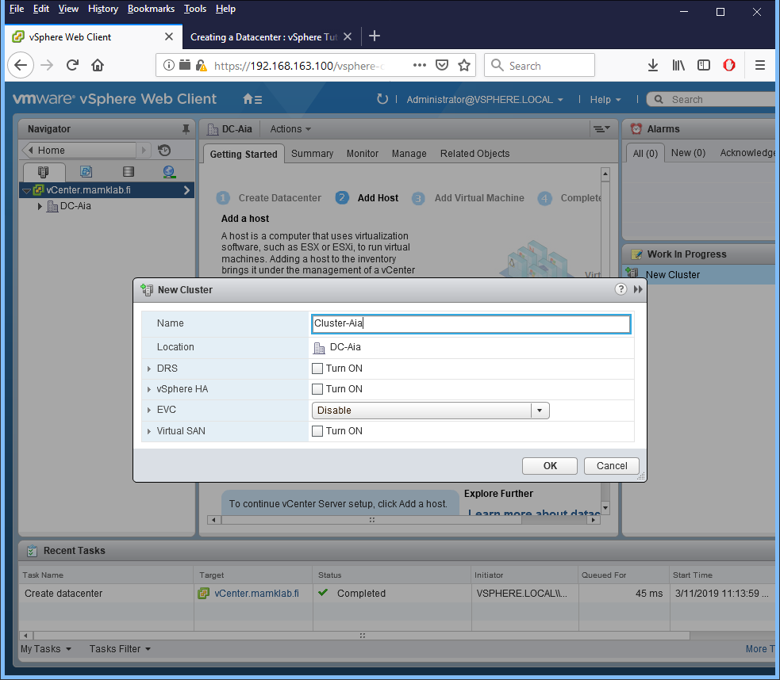

o Notice the cluster settings: DRS, vSphere HA, EVC, Virtual SAN are off by default (leave it that way, we will configure them later).

- Go to the Cluster and add the ESXi hosts **ESXi-01.mamklab.fi** and **ESXi-02.mamklab.fi** to the cluster (use the **root** / **P@ssw0rd** account).

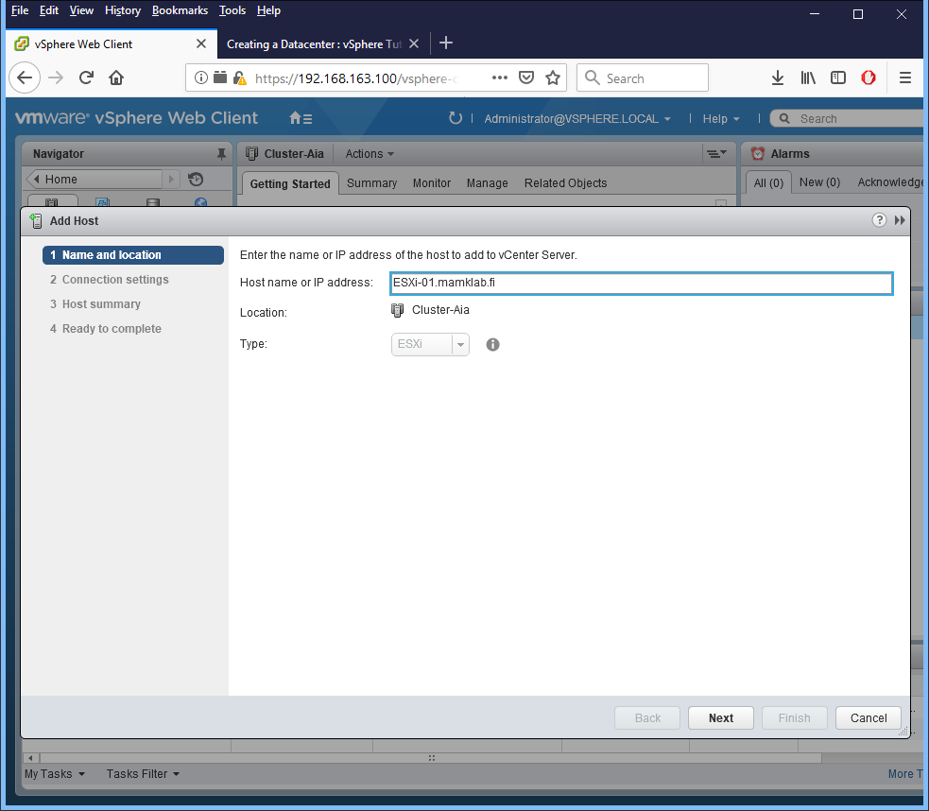

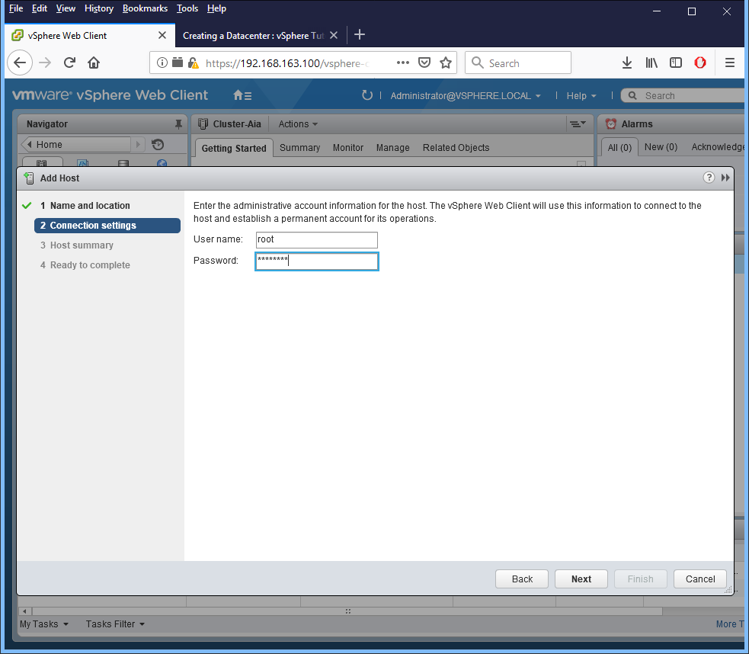

o Accept any certificate warnings.

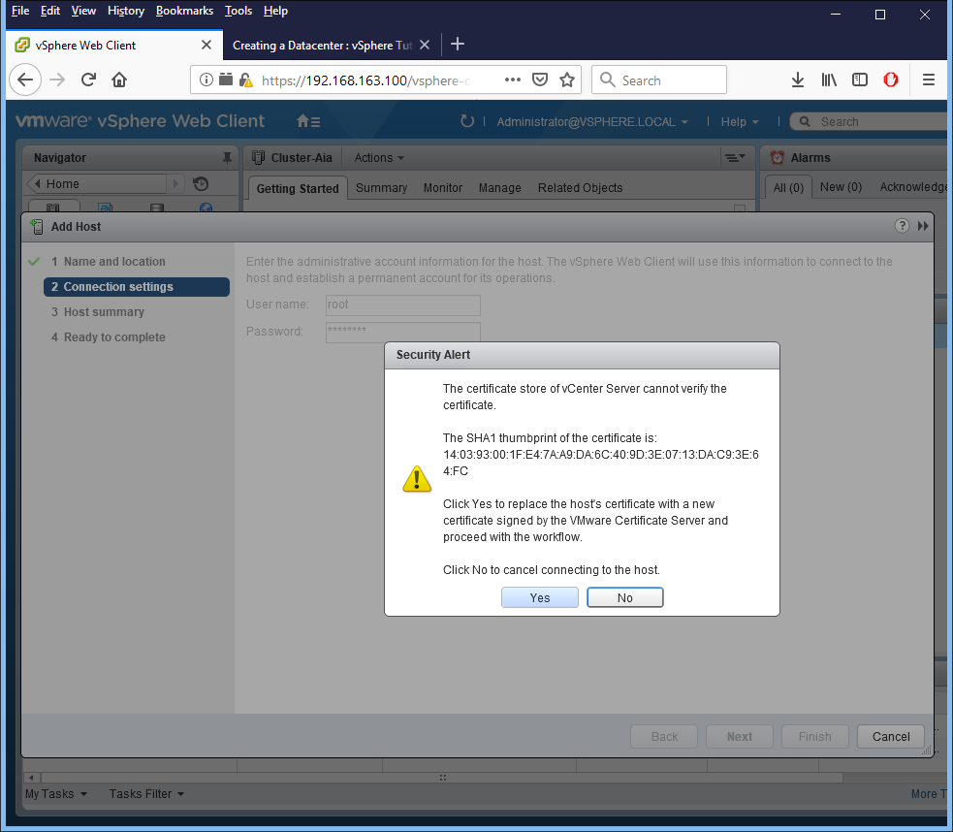

o Use **disabled** as the Lockdown mode. *In your* ***report****, describe what the lockdown mode means and how it is related to security.*

**A: When enabling lockdown mode, no users other than vpxuser have authentication permission or can perform operations against the host directly. It forces all operations to be performed through vCenter Server. Also its increasing the security of ESXi hosts.**

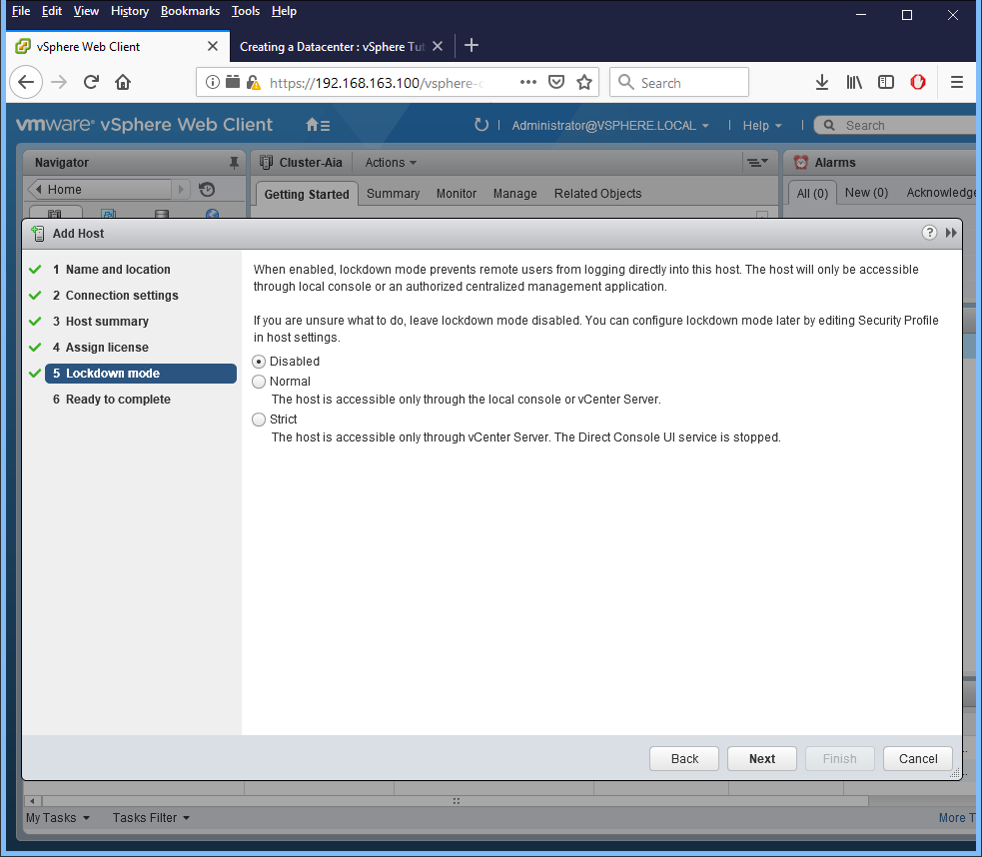

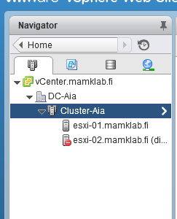

- For both ESXi hosts,

o Create a **new datastore**

▪ Name: **DS-host01-YourName** and **DS-host02-YourName**

▪ Use full space from the 100 GB disk for the datastore.

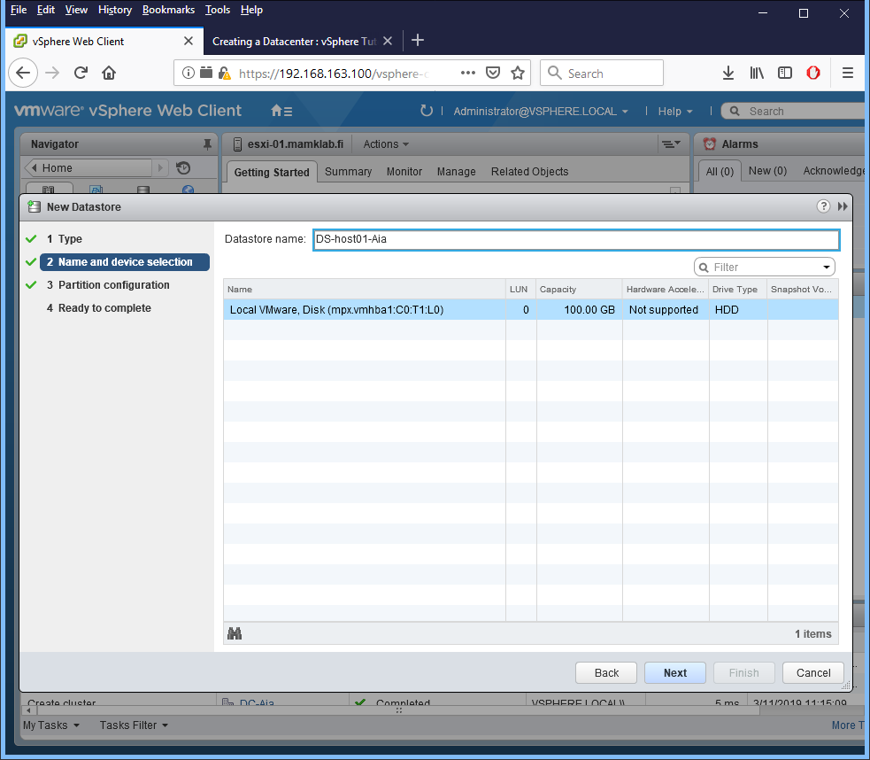

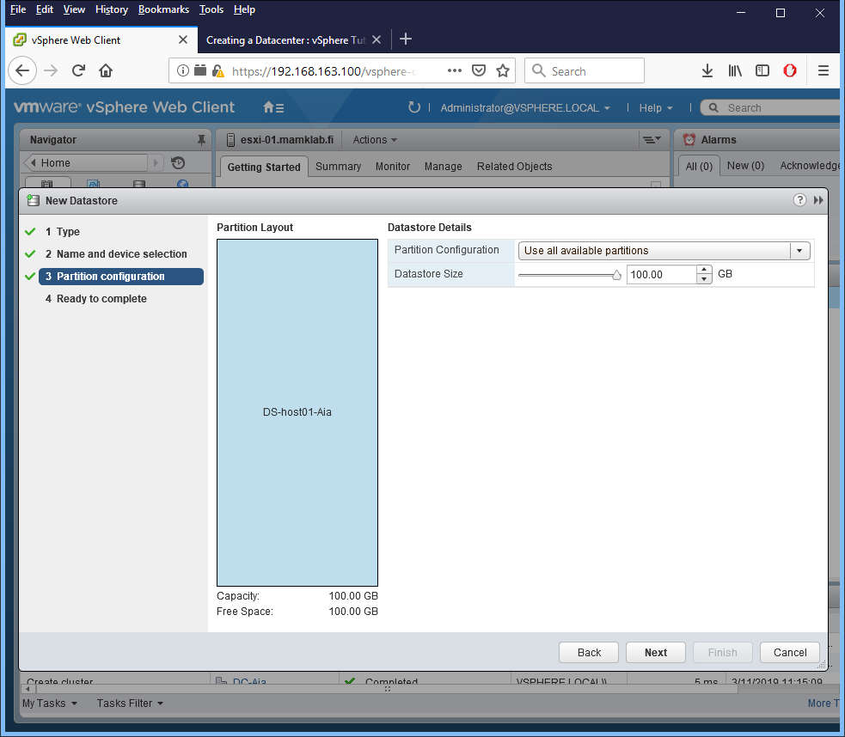

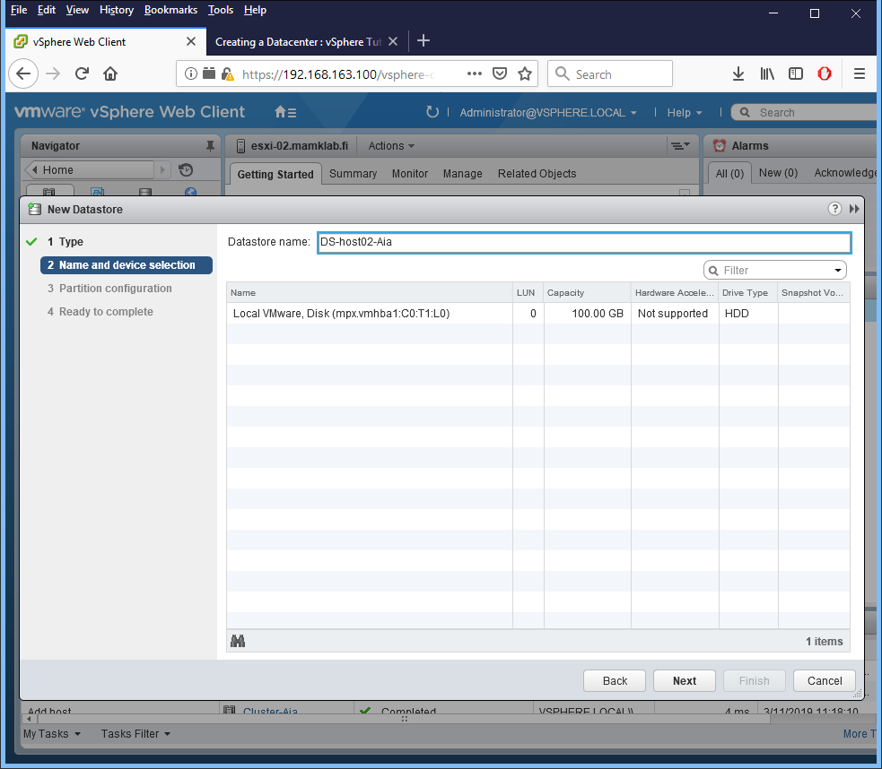

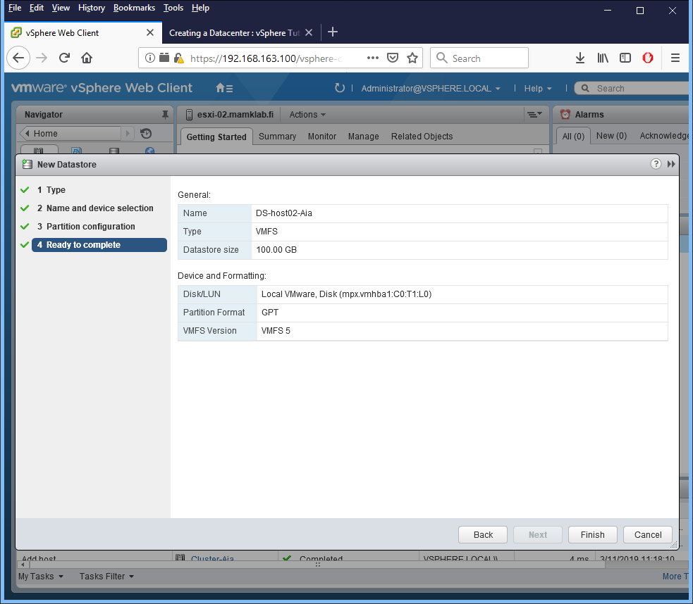

**Step 5. Configuring Redundancy and Load Balancing to the Cluster**

- There are two important technologies related to redundancy in the VMware environment: **vSphere Distributed Resource Scheduler (DRS)** and **vSphere High Availability (HA)**. *In your* ***report****, describe what these two technologies mean.*

**A: Enabling both DRS and HA can get more load balanced cluster’s results in the event of a failover, then there would be from HA alone. vSphere HA’s job is to get virtual machines back up and running as soon as possible following a host failure, the result is that certain hosts may become more heavily loaded than others.**

**DRS cluster is a collection of ESXi hosts and associated virtual machines with shared resources and a shared management interface.**

- Go to your cluster management and **turn on the DRS** with the following settings

o Automation Level: **Fully Automated**

o Explore the Migration Threshold and change it to **priority 4**

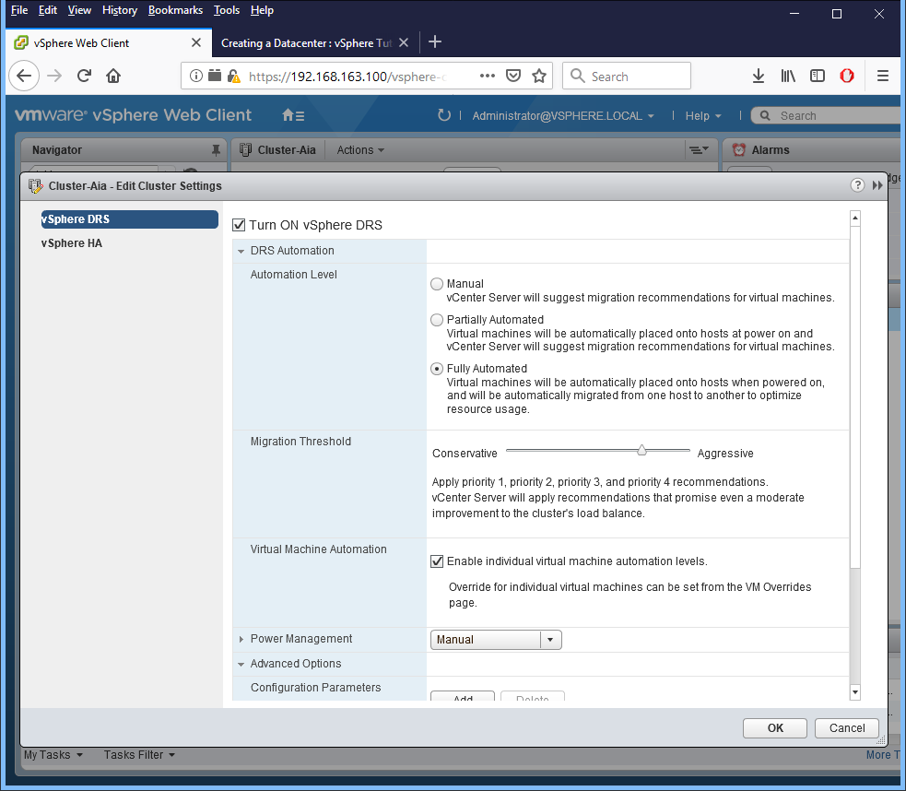

o Change Power Management to **Manual** (read the descriptions)

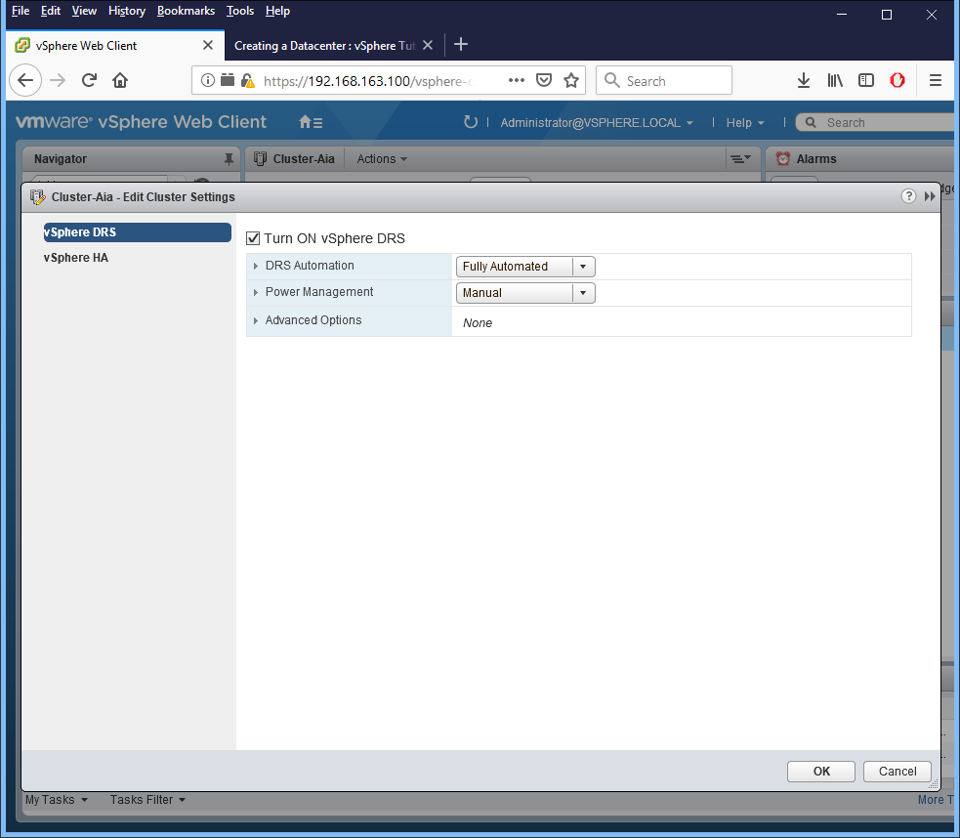

- Also **turn on the HA** with the following settings

o Enable **Host Monitoring**

o Enable Virtual Machine Monitoring: **VM Monitoring Only**

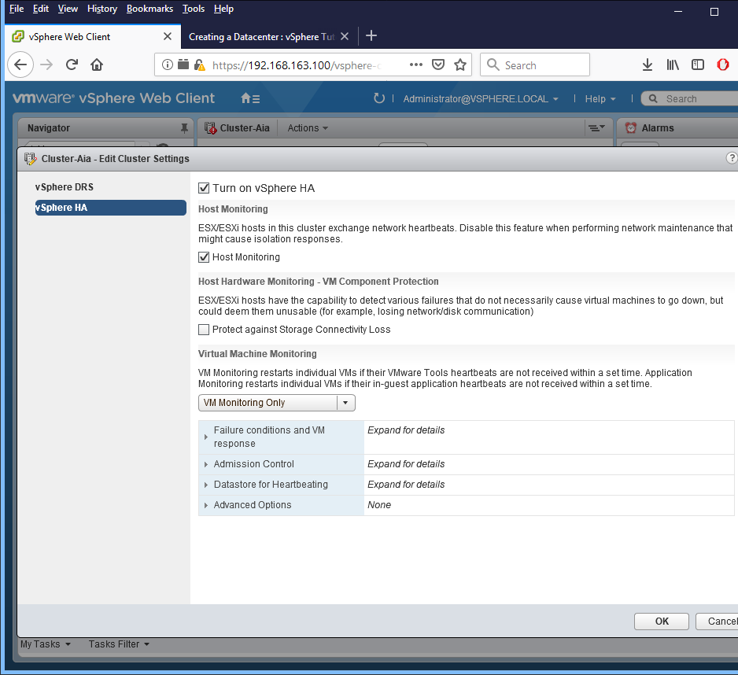

o Expand the **Failure conditions and VM response** configurations and *explain the configurations in your* ***report.***

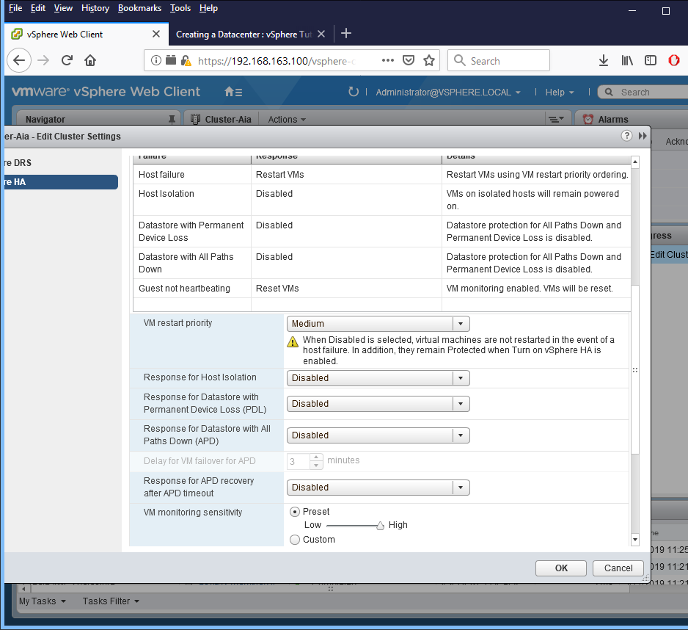

▪ The default settings are good for our needs, no need to change any settings.

o Configure Datastore for Heartbeating to Automatically select datastores accessible from the host

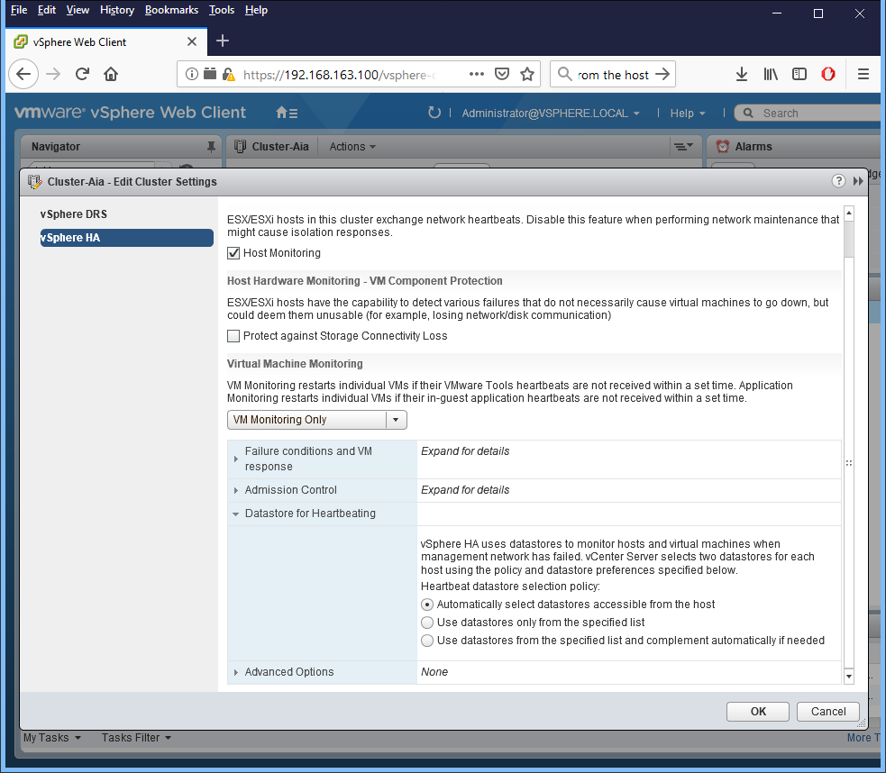

- Click the **Summary** tab for your cluster

o vSphere DRS should show you that the cluster resources are perfectly balanced (well, there are no resources yet)

o vSphere HA should show you that your environment is currently protected

o *Attach a* ***screenshot*** *of the Summary tab, showing the previous information to your* ***report****.*

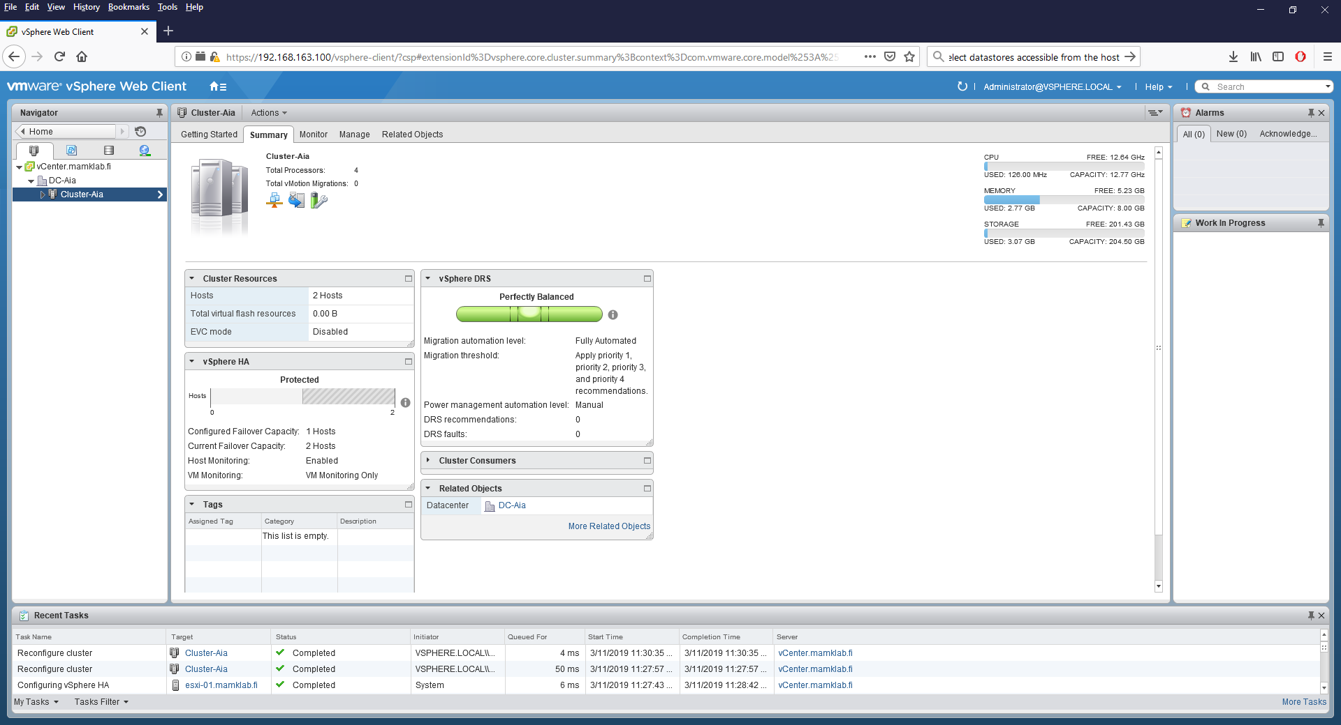

**Step 6. Deploying Virtual Machines to a Cluster**

- Practice deploying virtual machines to your **cluster** (select the cluster (not an individual host) as the target to allow automatic distribution of resources to the hosts) with different methods (**use at least two different methods to deploy at least two VMs**):

o **Note**: for every VM, use **Thin provisioning** for the hard disk to prevent running out of disk space

o **Create a new VM** (you can select what kind of VM you wish to use, for example LUbuntu with 512MB of RAM)

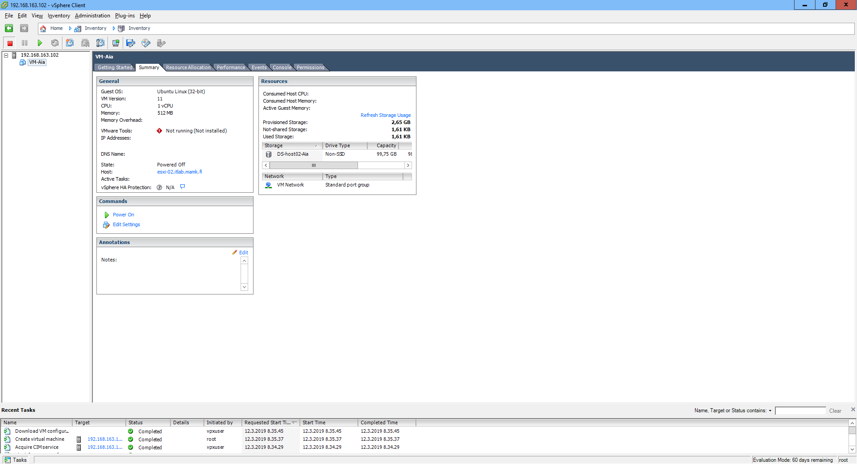

▪ Connect some ISO image from P:\Matti\ISO to the VM DVD drive and power on the VM.

o **Deploy a VM from a local template** (select some VM template from P:\Matti\VMware Images\)

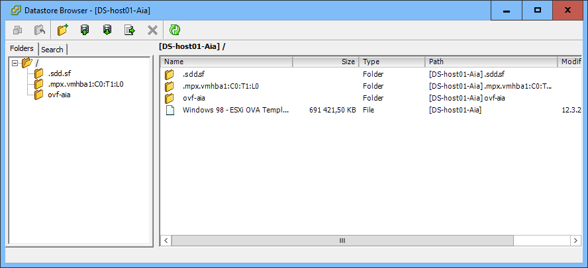

▪ Note that there is a bug in the vCenter Server, which may prevent you from deploying OVF templates directly with the Web Client. In that case, use vSphere Client to connect to the vCenter Server and deploy the VM template with that tool.

o Use a **Content Library** to deploy VMs

▪ Go to **Home** → **Content Libraries**

▪ Read the information about content libraries from the **Getting Started** tab

▪ Select the **Objects** tab and click on the "**Create a New Library**" button

▪ Name the Content Library as **VMLib-YourName**

▪ Use datastore from either **ESXi-01** or **ESXi-02** host, you can decide

▪ Go to your new content library and upload some **OVF** or **ISO** image there (again, if there are problems, try vSphere Client)

▪ Then, deploy a new VM from the Content Library 

o **Clone a virtual machine** from an existing virtual machine (you must have a VM in the cluster before you can do this)

o **Create your own template** and deploy a VM from the template.

o **Upload an existing VMware VM** to your cluster and continue running the VM there.

o At this point, **you should have at least two VMs running on your cluster**

o *In your* ***report****, describe the virtual machine deployment methods you tried and explain how the procedure went for each method. Screenshots are useful here!*

**Step 7. Gathering Information and Monitoring the Virtualization Environment**

- Now that you have some resources running in your environment, it is important to be able to follow what’s going on there.

- Explore the interface and find out how to get details and manage different objects, try at least the following:

o From **Home**, check the

▪ **vCenter Inventory Lists:** shows all objects across the vCenter Server in one place

▪ Hosts and Clusters 

▪ VMs and Templates 

▪ Storage 

▪ Networking 

▪ *Select some detail from the previous views and attach a* ***screenshot*** *and* ***explanation*** *to your* ***report****.*

o For **each resource** (for example datacenter, cluster or host) the tabs are important:

▪ **Getting Started**: displays the common tasks (can be disabled from Help (right top corner))

▪ **Summary**: the main information on the resource

▪ **Monitor**: possible issues/alarms, performance data, recently run tasks and events on the resource

• *Select some detail from here and attach a* ***screenshot*** *and* ***explanation*** *to your* ***report****.*

▪ **Manage**: allows to schedule tasks, alarms, permission, etc. for the resource

• *Create a scheduled task or an alarm and attach a* ***screenshot*** *and* ***explanation*** *to your* ***report****.*

▪ **Related Objects**: direct links for the other objects in the environment that are related to this resource.

▪ Also check the **Actions menu** that provides necessary actions related to this resource (also right-clicking the resource in the navigator shows the Actions menu)

o For the **virtual machines**

▪ Select some of your VMs

▪ Explore the **tabs** for this kind of resource

▪ Again, check the **Actions menu** and see the VM actions: Power, Snapshots, Migrate, Clone, Template, Fault Tolerance, Edit Resource Settings, Add Permission, Alarms

▪ Practice opening a **console** for a VM

• Try the console both locally in the **web browser** and remotely with **VMware Player**

o Also notice that

▪ Every view in the Web Client corresponds to an URL → you can **bookmark** the important views to the browser

▪ **Back and forward buttons** (on top of Navigator) allow easy browsing

▪ Tabs and subtabs remain constant when you select the object from left (easy to compare for example the load of the hosts).

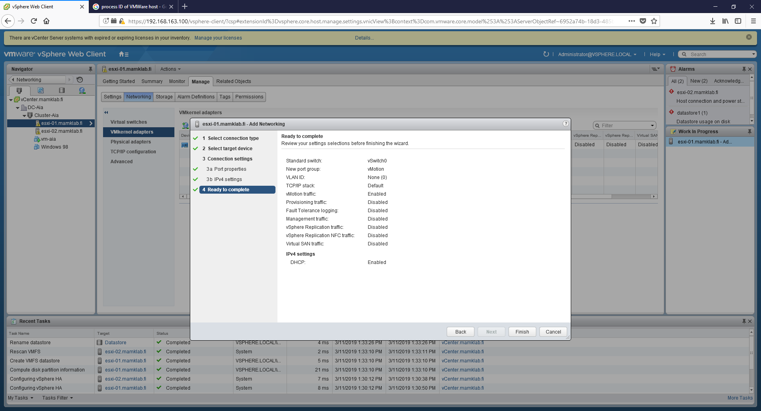

**Step 8. Testing vMotion in Practice**

- **vMotion** allows migrating VMs between the ESXi hosts

- vMotion requires you to configure each host with at least one network interface for vMotion traffic. For **both ESXi hosts**,

o Go to **Manage** → **Networking** → **VMkernel adapters**

o Click Add host networking

o On the Select connection type page, select **VMkernel Network Adapter**

o On the Select target device page, select the **existing standard switch (vSwitch0)**

o On the Port properties set **Network Label: vMotion** and **enable vMotion Traffic**

o Configure IPv4 settings: **Obtain IPv4 settings automatically**

o Review the settings and click **Finish**

- Then, browse to one of your virtual machines and check from the **Summary** tab where the VM is currently running

- **Migrate** the VM to the other host

o Change both the compute resource (=the actual VM that the server runs) and storage (=the virtual hard drive)

▪ **TIP**: you can see the action you are currently doing the **Work in Progress** pane on the right side, and you can also minimize and finish the work later: **>> button** in the right top corner of the wizard

▪ **TIP2**: the question mark button in the right top corner of the wizard is a direct link to VMware documentation

o Manually select the other ESXi host as the destination for both compute resource (=where the VM will be running) and storage (=where the VM storage will be located)

o Schedule the vMotion with **high priority** to make the migration happen immediately

o Review the settings and click **Finish**

o The live migration will take place immediately and the VM is usable all the time

▪ You can follow the migration process in the **Recent Tasks** on the bottom of the Web Client window

▪ *Attach a* ***screenshot*** *of the migration process taking place to your* ***report****.*

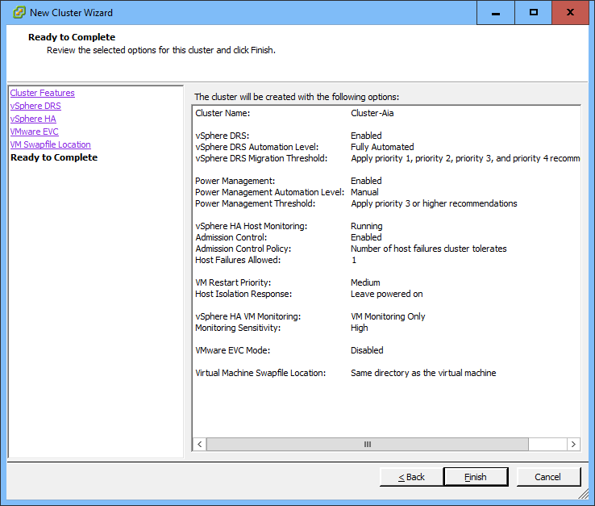

In order to successfully deploy the OVF images, we have to do that directly on the connection to the ESXi hosts. Anything that we do with vCenter would not work.

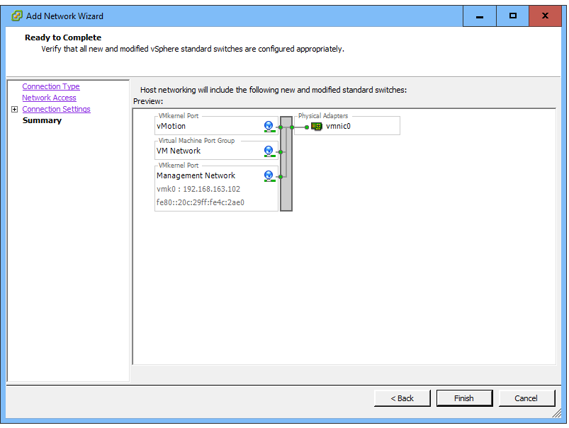

**Step 9. Testing vSphere DRS in Practice**

- vSphere DRS continuously monitors utilization across ESXi hosts and automatically allocates available resources among the VMs.

- Go to the **Summary** tab for your cluster and click the **Refresh** button on the top of the window

o Probably at this point, the **vSphere DRS** shows you that the cluster resources are **imbalanced** (as you manually migrated a virtual machine to another server)

▪ *Attach a* ***screenshot*** *of the imbalanced cluster to your* ***report****.*

o If the DRS shows balanced resources, migrate (or clone) more VMs to one of your hosts leaving the other with less load.

- Go to **Monitor** → **vSphere DRS** tab

o Investigate the Recommendations, Faults, History, CPU Utilization and Memory Utilization for the hosts

o Click **Run DRS Now** (from the Recommendations)

▪ This causes the DRS to check the load balance and do the necessary actions immediately. 

▪ However, the VM migrations also consume resources and DRS only migrates VMs if it sees there is a real need for it. So you don’t necessarily see any migrations taking place.

- The DRS automatically balances the load every now and then but you can create custom schedules as well:

o Go to the **Manage** tab and **Schedule a new DRS task** with the following settings:

▪ Task name: **DRS-balance**

▪ Configured Scheduler: **Immediately**

▪ Test running the task. The DRS will check the balance and do the necessary actions (again, not necessarily migrating anything, if the DRS considers the migration more costly than the resulting benefit…)

- You can also test the DRS by creating new resources and checking where they are placed

o Create a **clone** of an existing VM

o Select your datacenter as the location

o Select your cluster as the target for the compute resource (DRS automatically selects the actual host to be used for the VM)

o Select the default datastore suggested by the wizard

o Review the settings and click Finish

o Explore the VMs: the new VM should be placed on the host where there was most resources available.

- *Attach a* ***screenshot*** *of the virtual machine CPU utilization sum in your DRS cluster (cluster* → *Monitor* → *vSphere DRS* → *CPU Utilization) to your* ***report****.*

When we migrate both computing resource, we had to turn of the VM.



Live migration does not work because of some validation issues.

The DRS shows that load is imbalanced.

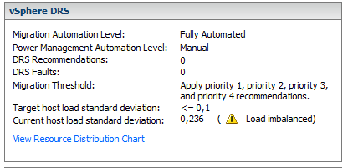

**It will start running the DRS**

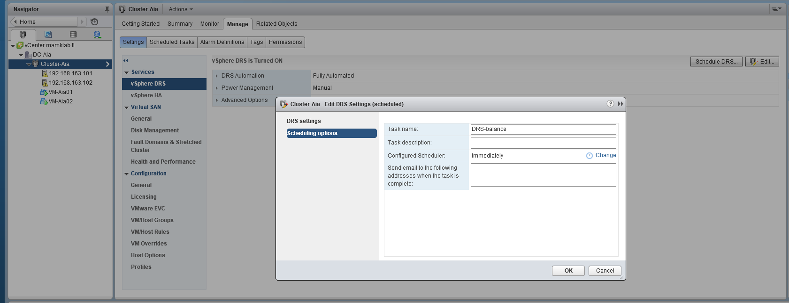

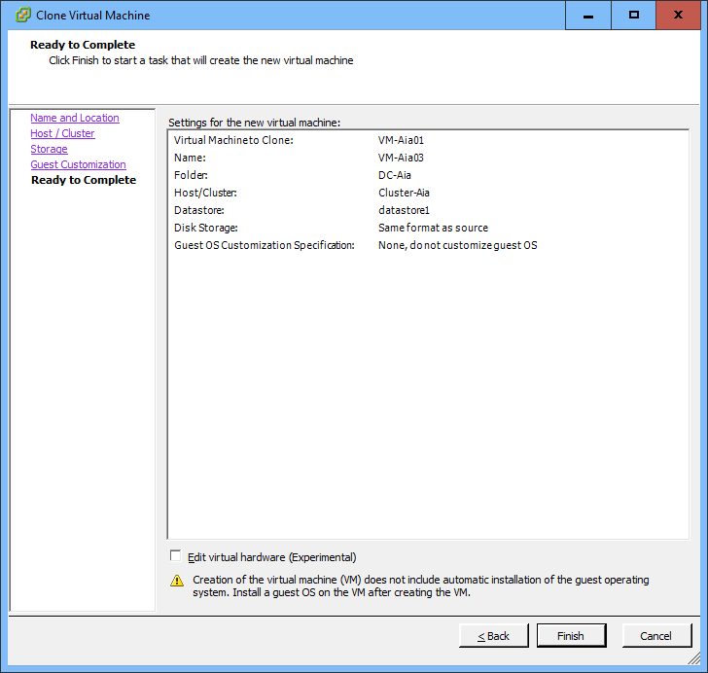

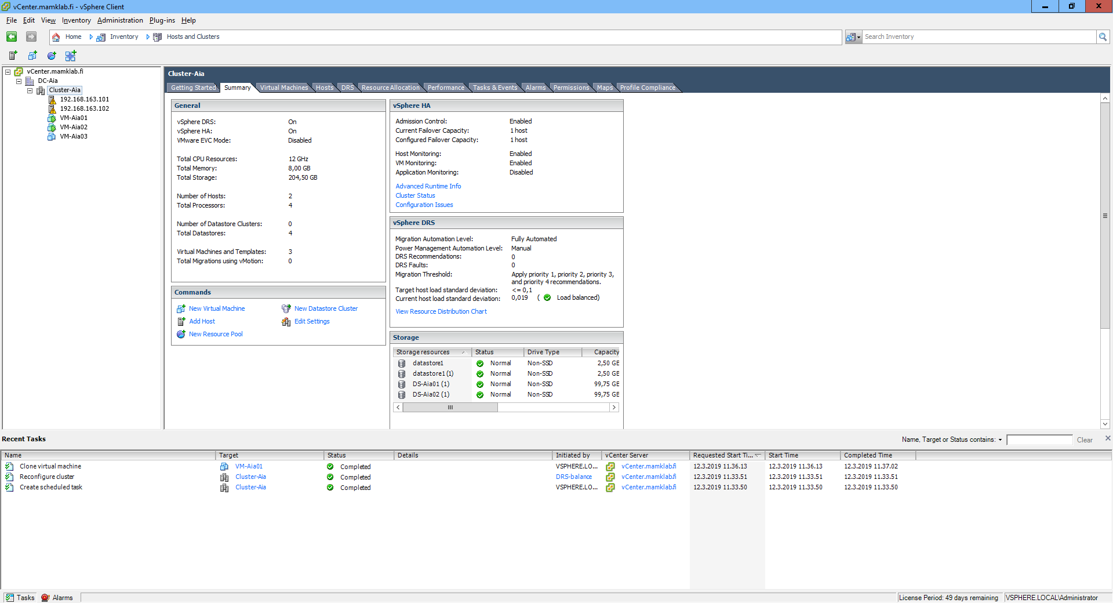

Finally, describe **in your report** your personal experiences about doing the lab and your experiences about VMware virtualization environment.

**A: We can deploy VMware vSphere with vCenter Server to manage multiple hosts at the same time, using vCenter sever to manage multiple hosts allows the administrator to experiment with advanced management options, such as resource sharing and all of the other options available within the vSphere environment.**

**There was problem with installing Client plug, the browser ssl didn’t support the certificate.**

**The VM lost the connection and got frozen during deploy the template and ISO images, we needed to configure it again when ever it’s getting stack.**